d

TOne Business Entities, Routing & Pricing

Contents

Document Purpose 2

TOne Main Business Entities 3

Suppliers 3

Sale Zones 4

Customers 4

Routing Product 5

Pricing Product 6

Routing Process 8

Routing Process Inputs 8

Routing Process Output 8

RoutingProductRoute 8

PricingProductRoute 8

CustomerRoute 8

Routing Full Process 9

Build Routes Sub Process 10

Execute Routing Rule 12

Retrieve Most Restricted Rule 12

Cost Analysis & Pricing 14

Pricing Product 14

Pricing Product Definition 14

Rate Planning 14

Pricing Rules 14

Assigning Customers to Product 15

Customer Pricing 15

# Document Purpose

The purpose of this document is to discuss the new structure of TOne business entities

# TOne Main Business Entities

The main entities in TOne are:

* Suppliers
* Sale Zones
* Customers
* Routing Products
* Pricing Products

## Suppliers

A Supplier is a Carrier Account that acts as a supplier. Each supplier has its own Zones definition and its own rates:

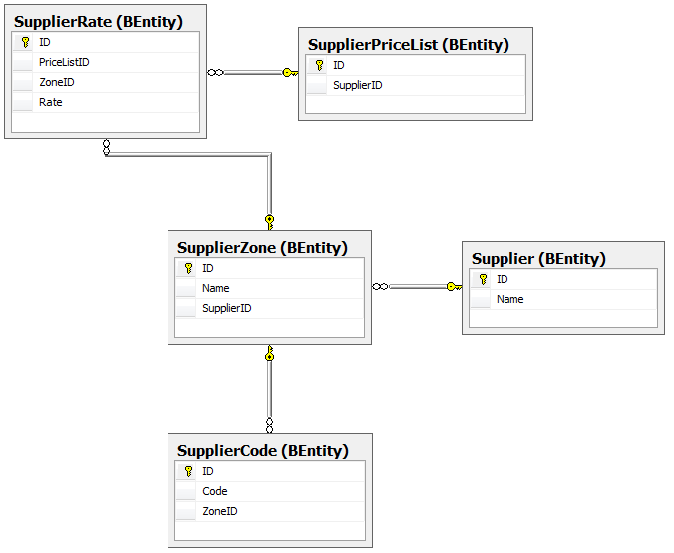

## Sale Zones

A client would be able to define one or multiple Code Addressing plans used to design its sales strategy. The Code Addressing plan is represented by the Sale Zone Package. A Sale Zone Package consists of a set of Sale Zones each of which consists of a set of Sale Codes

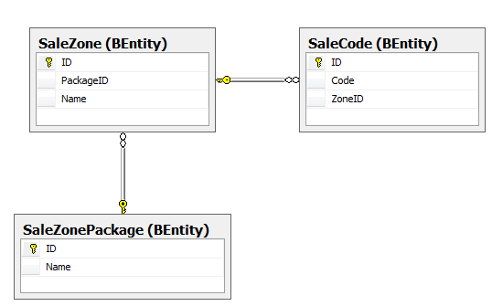

## Customers

A Customer is a Carrier Account that acts as a customer. A Customer should be assigned a single Sale Zone Package. The Sale Zone Package is assigned one time and cannot be changed in the future

The main attributes of the Customer are:

|  |  |
| --- | --- |
| Attribute | Notes |
| Name | String value |
| Sale Zone Package | This value is assigned at creation time and cannot be changed |

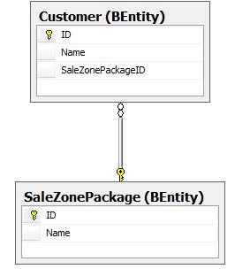

## Routing Product

The purpose of a Routing product is to provide the customer with voice service at a specific cost and quality. A Routing Product consists of a group of zones and it is configured with a routing strategy

The main attributes of the Routing product are:

|  |  |
| --- | --- |
| Attribute | Notes |
| Name | String value |
| Sale Zone Package | This value is assigned at creation time and cannot be changed |
| Sale Zones | * All * Specific Zones   Each Zone would have a specific Service Flag |
| Suppliers | * All * Specific Suppliers |
| Routing Rules | Each routing rule would consist of the followings:   * Criteria:   + Zones * Action:   + Route Type     - Fixed Route     - Automatic Route   + Percentage Settings   + Exclude Options   + Order Options |

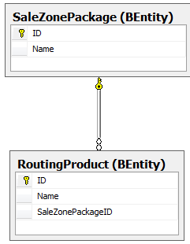

## Pricing Product

The purpose of the Pricing product is to define a pricing strategy and assign it to a group of customers.

The main attributes of the Pricing product are:

|  |  |
| --- | --- |
| Attribute | Notes |
| Name | String value |
| Sale Zone Package | This value is assigned at creation time and cannot be changed |
| Routing Product | The default Routing Product used for Cost analysis in order to decide selling rates |
| Rates | The rates decided on the product |
| Pricing Rules | Rules defined on the product that restrict the prices defined by the account managers on the related customers. Each rule would consists of:   * Criteria:   + Zones   + Customers * Action:   + Locked Rate   + Open Rate with Margin Settings |

Each customer should be assigned to a single Pricing product at a specific point of time:

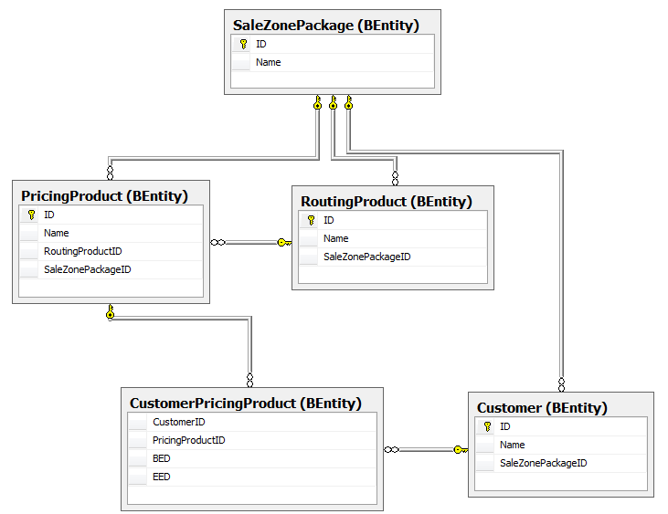

# Routing Process

This section discusses the Routing process.

## Routing Process Inputs

The routing process basically relies on the following inputs:

* Customer
* Sale Zones
* Sale Rates
* Supplier
* Supplier Zones
* Supplier Rates
* Routing Products
* Routing Rules

## Routing Process Output

The output of the Routing Process is a new routing database consisting of the following tables:

### RoutingProductRoute

This table stores the route options by Sale Zone for each Routing product:

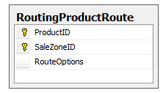

### PricingProductRoute

This table stores the route options by Code for each Pricing product. This table acts as shared routing for multiple customers:

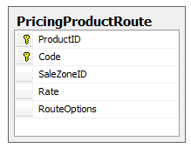

### CustomerRoute

This table stores the route options by Code for each customers:

* In case the customer has a specific route options, the Route shall be stored in this table
* In case the customer is sharing the route options with other customers, the Route shall be stored in and retrieved from the PricingProductRoute table

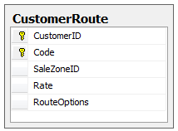

## Routing Full Process

The main Routing process relies on the concept of dividing distinct codes into a set of code prefixes where each prefix could be processed independently. And then for each code prefix, a separate sub process would be initialized. The full process is depicted in the following diagram:

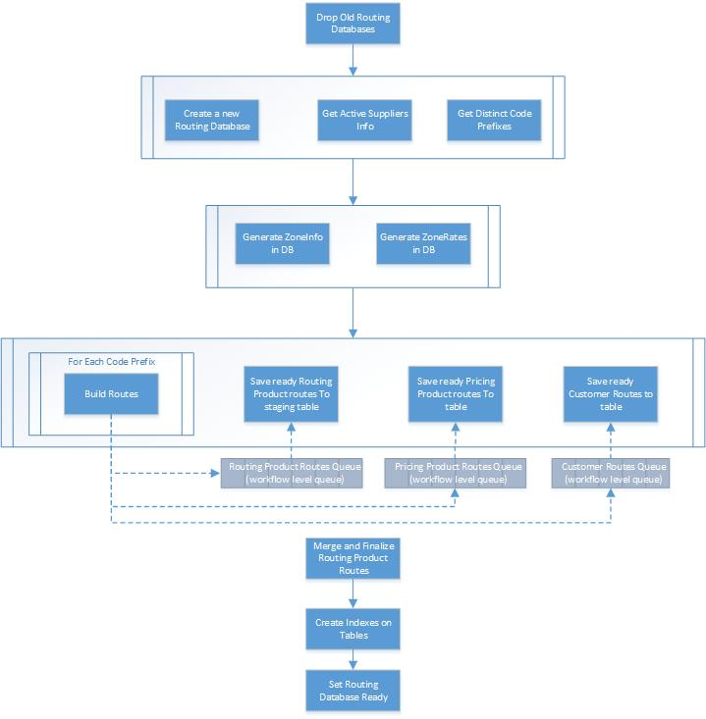

### Build Routes Sub Process

The Build Routes sub process takes a code prefix as input, and it builds routes on three levels:

* Routing Product routes by Code
* Pricing Product routes by Code
* Customer routes by Code

It is depicted in the following diagram:

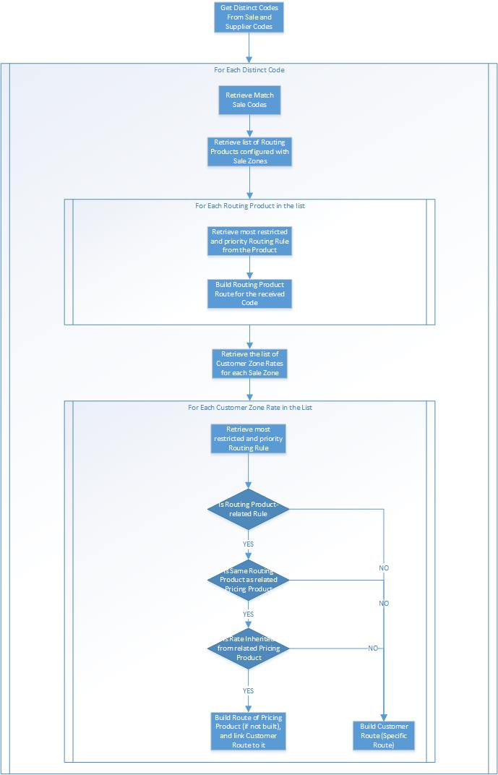

### Execute Routing Rule

The main logic of building the Route Options is executed by the applicable Routing Rule. The Routing rules to execute are retrieved in the Build Routes sub process on two levels:

1. By Routing Product
2. By Customer

The main execution flow of the Routing rules is depicted in the following diagram:

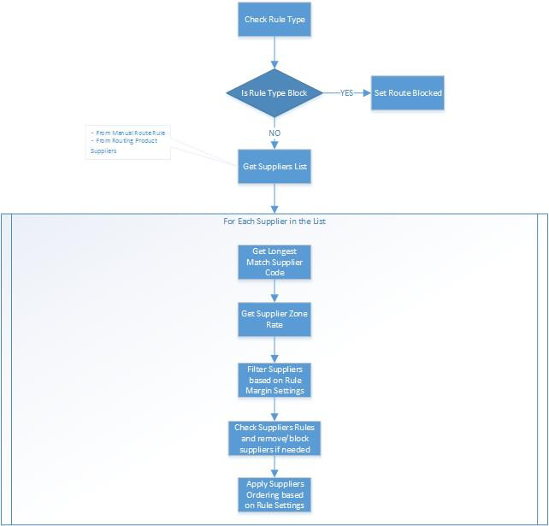

### Retrieve Most Restricted Rule

The following diagram shows the sequence of checks to retrieve the most restrictive and priority rule to execute on a Customer level in order to build the Route Options:

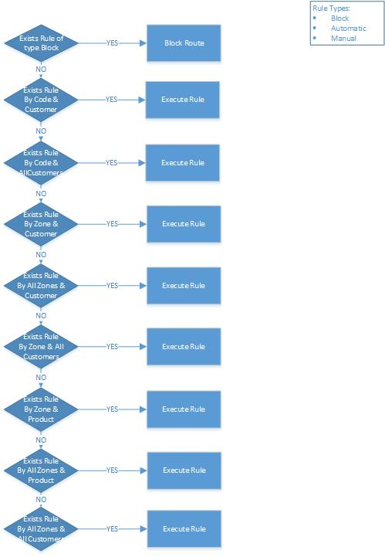

# Cost Analysis & Pricing

Cost Analysis and Pricing is performed on two levels:

* Pricing Product
* Customer

## Pricing Product

The purpose of the Pricing product is to define a pricing strategy and assign it to a group of customers. The management screen of the pricing product shall consist of the following sections:

### Pricing Product Definition

In this section, the user:

* Sets the name and the description of the Pricing Product
* Assigns default Routing Product

### Rate Planning

In this section, the user sets a rate on each sale zone after doing Cost Analysis. To do Cost Analysis, the system relies on the Routes produced by the Routing process on the Routing product level. The Routing product is set on the Pricing product level and can be also overriden on the Zone level.

After doing rate planning, the rates are stored in the database for the Pricing product. Those rates are used as initial values on the Customers assigned to the pricing product.

Whenever the user does rate planning and clicks Apply, a new record in the SalePriceList table having OwnerType equals to Pricing Product type. And each rate record is stored in the SaleRate table:

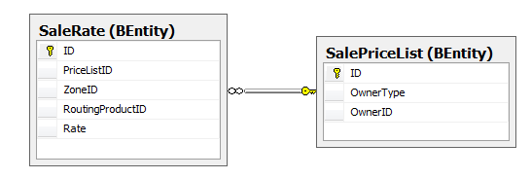

### Pricing Rules

In this section, the user defines the pricing rules that control and restrict the rates defined by the account managers on the customer level. A pricing rule consists of:

* Criteria:
  + All Zones or specific Zones
  + All Customers or specific Customers (from the list assigned to the product)
* Action:
  + Locked Price
  + Open Price with Margin settings. The margin settings can be defined based on the User Level

### Assigning Customers to Product

In this section, the user assigns customers to the pricing product. The following rules shall apply:

* Each customer should be assigned to a single pricing product at a specific point of time
* In this section, the user can select the Effective time of the assignment
* The user can select one of the two options:
  + “Force Destinations”: The customer takes all destinations of the product with no exceptions. In this case, the customer inherits default rates and pricing rules from the product.
  + “Flexible Destinations”: The customer takes specific destinations. In this case, the customer only inherits pricing rules from the product

This relation is stored in the CustomerPricingProduct table

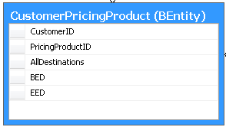

## Customer Pricing

The pricing on the customer level shall be in the rate planning screen (same one of the Pricing product).

In order to do pricing, the customer should be first assigned to a Pricing product as discussed previously. This task shall be done by a senior manager (a User who has permission to assign customers to products). If, during assignment to Pricing product, the option “Flexible Destinations” is selected, the Account Manager shall then select the destinations to sell to the customer.

In this screen, the Account Manager shall initially see the rates based on the Pricing product rates. He can do cost analysis based on the selected routing product (same as Pricing product). He can change routing products and rates on a Zone per Zone basis (if Pricing rules allow). The margin rules defined on the pricing product shall be evaluated on each rate and the screen shall notify the account manager if any approvals is needed.

Whenever an Account Manager does rate planning and clicks Save Price List, a new record in the SalePriceList table having OwnerType equals to Customer and the rates would be stored as follows:

* If the customer is tagged with “Force Destinations” (in customer-product assignment), only changed rates (value or routing product) would be stored in the SaleRate table, and the rest unchanged destinations would inherit rates from the Pricing product’s rates
* If the customer is tagged with “Flexible Destinations”, all customer rates would be stored in the SaleRate table

